TIME LORD / TARDIS RPG
Step-by-Step World Builder's Manual
Building a playable Doctor Who-style DeltaWorlds experience around TimeLordBot

CURRENT BASELINE This manual is written for the V4 Final / Build Fix 7 Live GameMaster build, including object clicks, object bumps, avatar clicks, proximity-emulated avatar bumps, zone enter/exit detection, conversational triggers, HUD, RPG systems, and the live GM editor.

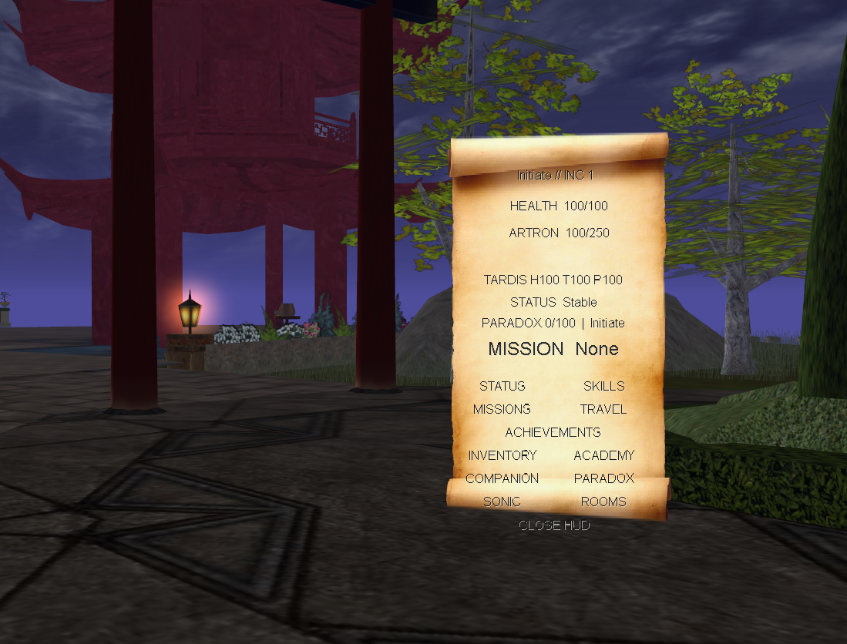
In-world Time Lord HUD after the corrected depth order.
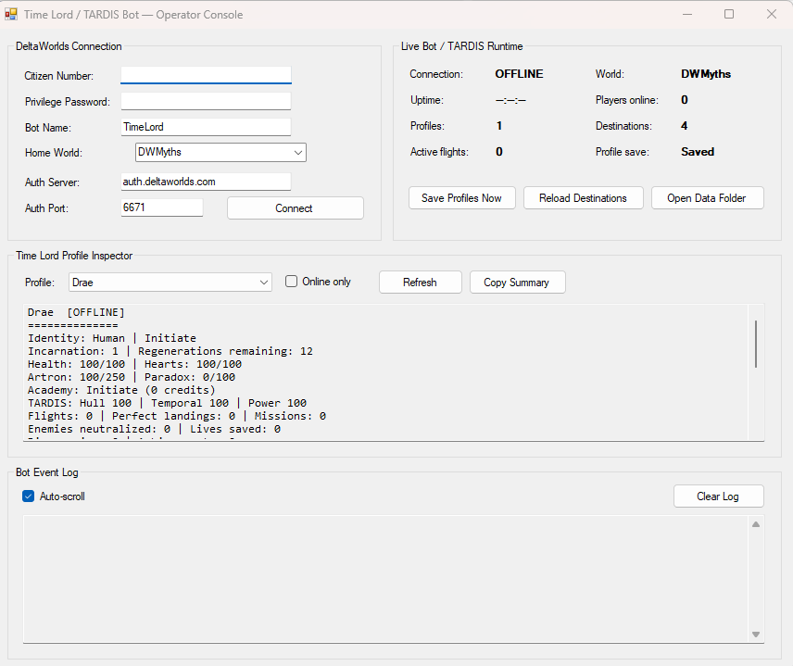
The Windows operator console / GameMaster workstation.

How to Use This Manual
This is a build-order manual, not just a command list. The first half tells you what to place and why. The second half is a reference catalogue for actions, triggers, chat, encounters, missions, dialogue, and GameMaster operations.
THE CORE BUILDING PRINCIPLE Use ACTIVATE for deliberate interaction; BUMP for physical or environmental contact; ZONE ENTER/EXIT for location state; AVATAR CLICK for targeting another character; AVATAR PROXIMITY for incidental character contact; CHAT for diegetic speech and choices; HUD for player information.

Recommended order
1. Freeze a known-good bot build and back up the runtime folder.
2. Prepare the object path and HUD textures.
3. Build the TARDIS console room as the game's central hub.
4. Build the Medical Bay, Workshop, Library/Matrix, Cloister Room, Zero Room, and Wardrobe.
5. Create navigation destinations and test same-world and cross-world travel.
6. Add environmental hazards and zone triggers.
7. Add sonic targets, discoveries, skill challenges, and inventory rewards.
8. Add NPC dialogue and conversational triggers.
9. Add encounters and enemies.
10. Author the first complete adventure from distress call to return trip.
11. Use the Live GameMaster workstation to tune content while players are in-world.

Document map
Part | What you will build
I | Deployment, backups, folders, HUD textures, and live data files
II | The TARDIS console room and all core flight controls
III | Functional TARDIS rooms
IV | The outside world: hazards, zones, discoveries, sonic puzzles, items
V | NPCs, conversational dialogue, avatar interactions, encounters
VI | Missions and the first complete playable adventure
VII | Live GameMaster workflow
VIII | Testing, balancing, and release checklist
Appendix A | Object-action command reference
Appendix B | Chat and natural-language reference
Appendix C | Trigger-file formats and examples

PART I — Prepare the Runtime and the World

Step 1 — Freeze a Known-Good Runtime
Before placing content, make one folder that you do not modify except when you intentionally promote a tested build. This is your gold-master runtime.
- Keep the compiled TimeLordBot executable and its configuration together.
- Keep AW.Core.dll and aw.dll beside the executable.
- Keep TardisDestinations.txt beside the executable.
- Allow TimeLordProfiles.xml and EnemyStates.xml to be created and updated by the bot.
- Keep ConversationTriggers.txt, ZoneTriggers.txt, and AvatarTriggers.txt beside the executable for live editing.
- Keep a dated backup of TimeLordProfiles.xml and EnemyStates.xml before major live events.
DO NOT USE Users.txt The standalone bot persists characters in TimeLordProfiles.xml. The old DWMyths Users.txt is not part of the TimeLord RPG runtime.

Step 2 — Prepare the DeltaWorlds Object Path
The HUD images are client-side world assets. They must be available in the world object path under the filenames referenced by the bot. Keeping the PNG files beside the EXE is not enough for players to see them.
- Upload the HUD textures to the world object path.
- Preserve filenames exactly.
- At minimum, ensure ghud-container2.png and the HUD icons currently used by the bot are available.
- Test the HUD with /hud on before building the rest of the world.
Player test commands
/hud on
/hud off
/hud

Step 3 — Understand the Live Data Files
File | Purpose | Edit live?
TardisDestinations.txt | Named TARDIS destinations across DeltaWorlds worlds | Yes — Destinations tab / Save + Reload
ConversationTriggers.txt | Speech patterns that cause gameplay | Yes — Conversation tab / Save + Reload
ZoneTriggers.txt | Zone enter/exit reactions | Yes — Zones tab / Save + Reload
AvatarTriggers.txt | Avatar click and proximity interactions | Yes — Avatars tab / Save + Reload
TimeLordProfiles.xml | Persistent player characters and TARDIS state | Use Profile Editor / gameplay systems
EnemyStates.xml | Persistent encounter state | Use Enemies tab

LIVE EDITING The GameMaster workstation can change destinations and trigger tables while the bot is running. Prefer its structured grid editors over hand-editing raw files; use the Raw Files tab when you intentionally want direct text control.

PART II — Build the TARDIS Console Room
Treat the console room as the central gameplay machine. Every visible control should either operate the ship, expose character information, launch content, or manage emergencies. Avoid decorative buttons that look usable but do nothing unless that is an intentional joke.

Step 4 — Divide the Console into Functional Sectors
Sector | Suggested visual language | Gameplay role
Navigation / Temporal | Blue / cyan | Destinations, coordinates, travel, temporal systems
Flight Critical | Red | Helmic, handbrake, landing mode, dematerialisation
Engineering | Amber / brass | Artron transfer, repairs, ship condition
Life Support / Medical | Green | Life support, hearts, health, medbay
Psychic / Telepathic | Purple | Telepathic circuits, paradox, psychic systems
Information | White / neutral | HUD, status, skills, missions, travel log

BUILDING TIP Use consistent color and physical placement. Players should eventually be able to operate the console by memory instead of reading every object description.

Step 5 — Place the Navigation Controls
Control | Action | What it does
Destination directory | activate ~tardiscontrol type:destinations | Lists known destinations.
Reload navigation | activate ~tardiscontrol type:reloadnav | GM/testing control; reloads TardisDestinations.txt.
Named destination button | activate ~tardiscontrol type:coordinates,destination:Draeda | Replace Draeda with any configured destination.
Set interior anchor | activate ~tardiscontrol type:setinterior | Run once from inside the TARDIS to record the interior return point.

For common destinations, physical buttons are ideal. For a large navigation network, rely on the destination directory, chat, and live destination database rather than building hundreds of permanent buttons.

Step 6 — Place the Flight Controls
Physical control | Action
Helmic Regulator | activate ~tardiscontrol type:helmic
Artron Transfer +5 | activate ~tardiscontrol type:artron,amount:5
Artron Transfer +10 | activate ~tardiscontrol type:artron,amount:10
Artron Transfer +25 | activate ~tardiscontrol type:artron,amount:25
Architectural Anchor | activate ~tardiscontrol type:anchor
Life Support | activate ~tardiscontrol type:lifesupport
Telepathic Circuits | activate ~tardiscontrol type:telepathic
Landing Mode: Open | activate ~tardiscontrol type:landingmode,mode:open
Landing Mode: Sealed | activate ~tardiscontrol type:landingmode,mode:sealed
Handbrake | activate ~tardiscontrol type:handbrake
Dematerialisation Lever | activate ~tardiscontrol type:dematerialise

THE DEMATERIALISATION LEVER Make this physically distinctive. It is the payoff control. The other systems prepare the ship; this one commits the flight.

Step 7 — Place the Emergency / Safety Controls
Emergency control | Action
HADS On | activate ~tardiscontrol type:hads,mode:on
HADS Off | activate ~tardiscontrol type:hads,mode:off
HADS Test | activate ~tardiscontrol type:hadstest
Cloister Bell | activate ~tardiscontrol type:cloisterbell
Temporal Stabilizer | activate ~tardiscontrol type:stabilize
Ship Status | activate ~tardiscontrol type:status
Reset Flight Preparation | activate ~tardiscontrol type:reset
Paradox Readout | activate ~tardiscontrol type:paradox
Paradox Stabilizer | activate ~tardiscontrol type:stabilizeparadox

Step 8 — Place the Player / RPG Interface Controls
Panel | Action
HUD Toggle | activate ~tardiscontrol type:hud,mode:toggle
Current Mission | activate ~tardiscontrol type:mission
Distress Scanner | activate ~tardiscontrol type:distress
Generate Adventure | activate ~tardiscontrol type:adventure
TARDIS Rooms | activate ~tardiscontrol type:rooms
Inventory | activate ~tardiscontrol type:inventory
Companion | activate ~tardiscontrol type:companion
Academy | activate ~tardiscontrol type:academy

Step 9 — Test One Complete Flight
1. Turn the HUD on.
2. Use the destination directory and confirm the target exists.
3. Set coordinates for a configured destination.
4. Operate the Helmic Regulator.
5. Transfer Artron energy.
6. Engage the architectural anchor.
7. Engage life support.
8. Engage telepathic circuits.
9. Choose landing mode.
10. Check handbrake state.
11. Pull the dematerialisation lever.
12. Confirm the player arrives at the intended coordinates.
13. For same-world travel, confirm the exterior shell is present and can return to the interior.
14. For cross-world travel, confirm the player teleports to the named world and no local return shell is created there.
CROSS-WORLD RULE Cross-world TARDIS travel teleports the player to the destination world but does not attempt to create a TARDIS return object in the remote world.

PART III — Build Functional TARDIS Rooms

Step 10 — Medical Bay
The Medical Bay should be the primary recovery space. Give it a diagnostic terminal, medbay treatment station, heart monitor, and emergency revival equipment.
Object | Action
Medbay treatment | activate ~rpg action:medbay,difficulty:30
Emergency revive | activate ~rpg action:revive,difficulty:45
Heart repair | activate ~rpg action:heartheal,amount:20
Heart 1 trauma test | activate ~rpg action:heartdamage,heart:1,amount:25
Heart 2 trauma test | activate ~rpg action:heartdamage,heart:2,amount:25
Life-sign status | activate ~timelord type:hearts

DESIGN CHOICE Keep the heart-damage objects out of normal player reach unless they are part of a deliberate hazard, training simulator, or scripted adventure.

Step 11 — Workshop / Under-Console Engineering
Build a maintenance area where hull damage, temporal faults, and power failures are repaired. This makes Engineering a place-based activity rather than a menu command.
System | Damage action | Repair action
Hull | activate ~rpg action:tardisdamage,amount:20,system:hull | activate ~rpg action:repair,system:hull,difficulty:45
Temporal integrity | activate ~rpg action:tardisdamage,amount:20,system:temporal | activate ~rpg action:repair,system:temporal,difficulty:60
Power | activate ~rpg action:tardisdamage,amount:20,system:power | activate ~rpg action:repair,system:power,difficulty:50

Workshop room action
activate ~rpg action:roomuse,name:Workshop,difficulty:50

Step 12 — Library / Matrix
The Library is a natural home for Investigation, Archaeology, Xenobiology, Temporal Science, discoveries, lore terminals, story flags, and spoken questions.
activate ~rpg action:roomuse,name:Library,difficulty:45
activate ~rpg action:speciescatalog,species:Silurian,difficulty:45
activate ~rpg action:discover,id:matrix_terminal,name:Matrix Archive Terminal
Use ConversationTriggers.txt to let players literally ask questions in this room. Restrict the trigger by zone so the same sentence does not fire everywhere.

Step 13 — Cloister Room
activate ~rpg action:roomuse,name:Cloister Room
Use the Cloister Room for Artron recovery, reflection after high-risk missions, temporal stabilization, and story scenes involving the Cloister Bell.

Step 14 — Zero Room
activate ~rpg action:roomuse,name:Zero Room
Use the Zero Room as a recovery / isolation space for psychic overload, temporal displacement, regeneration sickness, or narrative scenes where the Time Lord needs to stabilize.

Step 15 — Wardrobe
activate ~rpg action:roomunlock,name:Wardrobe
activate ~rpg action:roomuse,name:Wardrobe
The current engine treats room use as gameplay state rather than a full costume system. Use the Wardrobe as a roleplay and story-transition space, and pair it with title/species/profile terminals if desired.

Step 16 — Room Unlock Progression
activate ~rpg action:roomunlock,name:Workshop
activate ~rpg action:roomunlock,name:Library
activate ~rpg action:roomunlock,name:Wardrobe
activate ~rpg action:roomunlock,name:Cloister Room
activate ~rpg action:roomunlock,name:Zero Room
Room unlocks work well as mission rewards. Do not unlock everything immediately unless you want the TARDIS fully functional from the start.

PART IV — Make the Outside World Reactive

Step 17 — Start with Environmental Hazards
Hazards are the simplest way to prove the world is no longer decorative. Use BUMP for physical contact and ZONE ENTER/EXIT for ongoing environmental areas.
Use case | Action / trigger row
Radiation object | bump ~rpg action:damage,amount:5,damagetype:radiation
Fire | bump ~rpg action:damage,amount:12,damagetype:fire
Temporal rift | bump ~rpg action:damage,amount:20,damagetype:temporal
Poison cloud | bump ~rpg action:status,name:Poisoned,duration:90,potency:2
Irradiated lab enter | Radiation Lab|enter|Your dosimeter screams.|~rpg action:status,name:Irradiated,duration:60,potency:2
Irradiated lab exit | Radiation Lab|exit|Radiation levels begin to fall.|~rpg action:cure,name:Irradiated

Step 18 — Place Skill Challenges
Every skill should eventually have a physical reason to exist in-world. Start with obvious terminals, machinery, ruins, locks, laboratories, and social checkpoints.
Object idea | Action
Engineering panel | activate ~rpg action:skillcheck,skill:Engineering,difficulty:55
Temporal engine | activate ~rpg action:skillcheck,skill:Temporal Science,difficulty:70
Ancient ruin | activate ~rpg action:skillcheck,skill:Archaeology,difficulty:60
Alien specimen | activate ~rpg action:skillcheck,skill:Xenobiology,difficulty:50
Security log | activate ~rpg action:skillcheck,skill:Investigation,difficulty:45
Psychic artifact | activate ~rpg action:skillcheck,skill:Psychic,difficulty:65
Sneak route | activate ~rpg action:skillcheck,skill:Stealth,difficulty:50
Diplomatic seal | activate ~rpg action:skillcheck,skill:Diplomacy,difficulty:55

Step 19 — Place Sonic Targets
Target | Action
Scan anomaly | activate ~rpg action:sonic,mode:scan,difficulty:30,result:Temporal residue detected
Analyze device | activate ~rpg action:sonic,mode:analyze,difficulty:40,result:The circuitry is non-human
Unlock electronic door | activate ~rpg action:sonic,mode:unlock,difficulty:45
Repair temporal panel | activate ~rpg action:sonic,mode:repair,difficulty:55,system:temporal
Interface with Gallifreyan terminal | activate ~rpg action:sonic,mode:interface,difficulty:60,result:Gallifreyan security handshake accepted
Medical scan | activate ~rpg action:sonic,mode:medical,difficulty:35
Life-sign scan | activate ~rpg action:sonic,mode:lifesigns,difficulty:35
Disrupt technology | activate ~rpg action:sonic,mode:disrupt,difficulty:55
Overload force field | activate ~rpg action:sonic,mode:overload,difficulty:70,result:The force field shorts out
Wooden door joke | activate ~rpg action:sonic,mode:unlock,difficulty:20,material:wood

Step 20 — Place Discoveries
Discoveries are excellent for hidden chambers, museums, ruins, alien technology, landmarks, and story clues. A player should feel rewarded for exploring rather than only fighting.
activate ~rpg action:discover,id:omega_vault,name:The Omega Vault
activate ~rpg action:discover,id:hand_of_omega,name:The Hand of Omega
activate ~rpg action:discover,id:matrix_terminal,name:Matrix Archive Terminal
Use a unique ID that will never be reused for a different discovery.

Step 21 — Place Inventory Rewards and Artifacts
activate ~rpg action:itemgive,id:matrix_key,name:Matrix Key,type:artifact,qty:1,skill:Temporal Science,bonus:5,description:Ancient Gallifreyan access key
activate ~rpg action:equip,id:matrix_key
activate ~rpg action:itemgive,id:medkit,name:Field Medkit,type:medkit,qty:2
activate ~rpg action:itemuse,id:medkit
activate ~rpg action:itemgive,id:artron_cell,name:Artron Cell,type:artroncell,qty:1
activate ~rpg action:itemuse,id:artron_cell
PARSER NOTE The parameter parser uses commas as separators. Avoid literal commas inside title, objective, result, name, description, and similar values unless the parser is later upgraded to support escaping.

PART V — NPCs, Dialogue, Avatar Interaction, and Encounters

Step 22 — Use Avatar Click as Target Selection
Clicking another avatar selects that player as the current interaction target. This gives multiplayer actions a natural UI: look at the person, click them, then speak or use an interaction.
Built-in contextual speech
scan target
scan them
scan
heal target
help target
stabilize target
stabilise target
Healing uses the actor's Medicine skill. This is especially useful for rescue scenes and multiplayer medical gameplay.

Step 23 — Configure Avatar Click / Proximity Triggers
AvatarTriggers.txt uses this format:
event|target|response|action
click|*|You focus your attention on {target}.|~rpg action:skillcheck,skill:Investigation,difficulty:20
click|Drae|A familiar biodata signature resolves.|~rpg action:reputation,faction:Gallifrey,amount:1
bump|*|You brush past {target}.|
AVATAR BUMP IMPLEMENTATION AW.Core does not expose a native EventAvatarBump. The bot emulates avatar-to-avatar bump from movement proximity using EventAvatarChange, a short distance threshold, and a cooldown. Treat it as proximity interaction, not pixel-perfect collision.

Step 24 — Configure Zone Enter / Exit
ZoneTriggers.txt uses:
zone|event|response|action
Radiation Lab|enter|Your dosimeter screams.|~rpg action:status,name:Irradiated,duration:60,potency:2
Radiation Lab|exit|Radiation levels begin to fall.|~rpg action:cure,name:Irradiated
Omega Vault|enter|Ancient Gallifreyan machinery stirs around you.|~rpg action:discover,id:omega_vault,name:The Omega Vault
Cyber Tomb|enter|Something wakes beneath the floor.|~rpg action:missionprogress,id:cyber_tomb,amount:1
Use zones for things that should happen because of location, not because the player remembered to click a button.

Step 25 — Build Conversational Dialogue
ConversationTriggers.txt turns ordinary roleplay speech into game input. It supports exact, contains, and starts matching, plus optional zone and story-flag requirements.
id|mode|pattern|zone|requireflag|response|action
Mode | Use it when | Example
exact | The phrase should be treated like a password or explicit choice | I am a Time Lord
contains | Natural sentences may include the key phrase | what is the matrix
starts | The beginning of the sentence defines the intent | Doctor I need

judoon_identity|exact|I am a Time Lord|Judoon Checkpoint||Species declaration received.|~rpg action:skillcheck,skill:Diplomacy,difficulty:45

matrix_question|contains|what is the matrix|Gallifrey Matrix||The Matrix whispers through the telepathic circuits.|~rpg action:storyflag,id:asked_about_matrix,value:1

vault_password|exact|Prydonian Chapter|Omega Vault|found_password|The lock recognizes the ancient phrase.|~rpg action:missionprogress,id:omega_mystery,amount:1
CONTEXT IS EVERYTHING Prefer zone restrictions and story-flag requirements for common words. The goal is for conversation to feel magical, not for ordinary chat to trigger random game systems.

Step 26 — Build Dialogue Nodes on Objects
activate ~rpg action:dialogue,text:State your business.,skill:Diplomacy,difficulty:55,successtext:The guard recognizes your authority.,failtext:The guard refuses passage.,setflag:citadel_access,faction:Gallifrey,reputation:2
activate ~rpg action:dialogue,requireflag:citadel_access,lockedtext:The seal remains closed.,text:The Matrix gate recognizes you.,skill:Temporal Science,difficulty:60,successtext:The gate opens.,setflag:matrix_open,missionid:matrix_mystery,progress:1
Use object dialogue for explicit interaction with a terminal/NPC prop; use conversational triggers when the player should be able to simply say the answer or question aloud.

Step 27 — Place Species-Aware Encounters
Encounter | Action
Dalek Scout | activate ~enemy id:dalek01,name:Dalek Scout,species:Dalek,hp:75,defense:68,attack:20,approach:investigate,rewardartron:15
Cyberman | activate ~enemy id:cyber01,name:Cyberman,species:Cyberman,hp:65,defense:58,attack:15,approach:sonic,rewardartron:12
Weeping Angel | activate ~enemy id:angel01,name:Weeping Angel,species:Weeping Angel,hp:100,defense:78,attack:25,approach:investigate,rewardartron:20
Sontaran Warrior | activate ~enemy id:sontaran01,name:Sontaran Warrior,species:Sontaran,hp:60,defense:52,attack:16,approach:combat
Judoon Captain | activate ~enemy id:judoon01,name:Judoon Captain,species:Judoon,hp:55,defense:50,attack:14,approach:diplomacy
Auton | activate ~enemy id:auton01,name:Auton,species:Auton,hp:50,defense:48,attack:12,approach:sonic
Renegade Time Lord | activate ~enemy id:renegade01,name:Renegade Time Lord,species:Time Lord,hp:70,defense:60,attack:15,approach:psychic

Resolution approaches can include combat, sonic, diplomacy/talk, stealth/evade, psychic, and investigate. Use the approach that best expresses the story problem rather than defaulting everything to combat.

PART VI — Author the First Complete Adventure

Step 28 — Build a Mission Spine
A good first mission should deliberately exercise the systems you just placed. Use this structure:
1. TARDIS receives a distress call.
2. Player checks the mission and navigation database.
3. Player prepares and flies the TARDIS.
4. Arrival zone fires an atmospheric or story trigger.
5. A discovery or clue invites Investigation / Sonic / Xenobiology.
6. An NPC can be questioned through conversational dialogue.
7. A hazard creates real health/status pressure.
8. An encounter can be solved by at least two approaches.
9. A story flag or mission progress unlocks the final interaction.
10. Mission completes and rewards the player.
11. Player returns to the TARDIS, heals/repairs, and reviews the travel log.

Step 29 — Example Mission: The Tomb Opens
Mission start
activate ~rpg action:missionstart,id:cyber_tomb,title:The Tomb Opens,objective:Investigate the Cyberman signal,required:3,destination:Draeda
Then distribute progress across the world rather than putting all three points on one object.
bump ~rpg action:missionprogress,id:cyber_tomb,amount:1
activate ~rpg action:discover,id:cyber_tomb_console,name:Cyber Tomb Control Console
activate ~enemy id:cyberleader_01,name:Cyber-Leader,species:Cyberman,hp:90,defense:70,attack:20,attackdifficulty:60,damagetype:energy,rewardartron:25,approach:sonic,missionid:cyber_tomb
Explicit completion if you want a final control
activate ~rpg action:missioncomplete,id:cyber_tomb

Step 30 — Make the Adventure Speak Back
Add at least three contextual conversation lines. A strong first adventure might include:
Player speech | Context | Consequence
What happened here? | Cyber Tomb zone | Investigation check or story flag
I am a Time Lord | Judoon / authority checkpoint | Diplomacy check
Shut down the conversion | Final chamber with correct flag | Mission progress / terminal action

Step 31 — Reward More Than Combat
Reward exploration, diplomacy, investigation, sonic problem-solving, rescue, and repair. The game should feel Doctor Who-ish because the best answer is often understanding the problem rather than destroying it.
- Discovery rewards for finding hidden rooms or lore.
- Academy credits for successful resolutions.
- Faction reputation for social choices.
- Artifacts or components for meaningful finds.
- Companion loyalty for decisions that affect companions.
- Room unlocks for major milestones.
- Artron energy for resolving temporal threats.

PART VII — Run the World from the Live GameMaster Workstation

Step 32 — Use the Overview Tab
Use Overview as your live health screen. Watch connection state, world, uptime, player count, profile count, destinations, active flights, profile-save status, and the selected profile summary.

Step 33 — Edit Destinations Live
Use the Destinations tab to add or change navigation rows. Save + Reload validates the row and updates the navigation database without restarting the bot.
Name|World|X|Y|Z|Yaw|ArtronCost|aliases|NavigationDifficulty
Draeda|DWMyths|-20853|800|-17750|3580|10|draeda|30
Gallifrey|DoctorWho|1234|500|-6789|1800|25|gallifrey,capitol|70

Step 34 — Edit Conversation Live
Use the Conversation tab to add a trigger while players are standing in the scene. Test Trigger lets you check a pretend line, zone, and profile without firing the action.
1. Add a unique trigger ID.
2. Choose exact, contains, or starts.
3. Enter the phrase.
4. Restrict it to a zone if appropriate.
5. Add a required story flag if this is a later branch.
6. Write the bot response.
7. Attach the normal RPG action consequence.
8. Use Test Trigger.
9. Save + Reload.
10. Ask the player to speak naturally in-world.

Step 35 — Edit Zones and Avatar Interactions
Use the Zones and Avatars tabs for enter/exit, click, and proximity interactions. These are excellent for tuning live events without moving or rebuilding objects.

Step 36 — Use the Profile and Enemy Editors Carefully
The Profile Editor is best for correcting test state, repairing a stuck character, or intentionally staging an event. The Enemies tab is best for inspecting and resetting persistent encounters.
GM SAFETY Before major live edits, use Save Profiles Now and keep backups of TimeLordProfiles.xml and EnemyStates.xml. Treat direct profile edits as administration, not the normal player progression path.

Step 37 — Use the GM Action Runner
The GM Action tab sends the exact same gameplay actions used by world objects to an online target. This is ideal for live events, testing, emergency fixes, and dramatic intervention.
~rpg action:heal,amount:25
~rpg action:damage,amount:10,damagetype:physical
~rpg action:artron,amount:25
~rpg action:paradox,amount:15,source:GM event
~rpg action:itemgive,id:matrix_key,name:Matrix Key,type:artifact,qty:1
~timelord type:status
~tardiscontrol type:status

PART VIII — Testing, Balance, and Release

Step 38 — Test the Interaction Matrix
Interaction | Test | Pass condition
Activate | Click an RPG object | One intended action fires
Object bump | Walk into a bump object | Bump action fires once per contact behavior
Avatar click | Click another player | Target selection / configured click trigger works
Avatar proximity | Move two avatars together | Configured proximity trigger fires without spam
Zone enter | Enter named zone | Enter response/action fires
Zone exit | Leave named zone | Exit response/action fires
Conversation | Speak matching phrase | Only the intended contextual trigger fires
HUD | Toggle HUD | Stable, readable, clickable
Cross-world flight | Fly to another world | Teleport succeeds; no remote return object is created

Step 39 — Balance Difficulty
Start conservative. A difficulty should communicate the dramatic weight of the task, not punish new characters for existing.
Difficulty | Suggested use
20–30 | Routine operation, tutorial, low-risk scan
35–45 | Normal field task
50–60 | Meaningful challenge
65–75 | Expert / dangerous
80+ | Exceptional, endgame, or heavily prepared task

Because skills are use-based and trivial checks stop yielding meaningful advancement, scatter tasks across difficulty bands rather than making every object Difficulty 30.

Step 40 — Ship the First Playable Slice
- One fully operational TARDIS console room.
- At least three useful TARDIS rooms.
- At least four destinations.
- At least one hazardous zone.
- At least three sonic targets.
- At least three discoveries.
- At least one NPC conversation chain.
- At least one species-aware encounter.
- One mission with start, progress, and completion.
- One reward beyond simple Artron gain.
- A tested return path to the TARDIS.
STOP ADDING SYSTEMS FOR A MOMENT Once this slice works, build more adventures and places before changing the engine again. The bot already has enough systems to support a large amount of content.

APPENDIX A — Master Object Action Reference

A1 — TARDIS Controls
Type | Example
coordinates | activate ~tardiscontrol type:coordinates,destination:Draeda
destinations | activate ~tardiscontrol type:destinations
reloadnav | activate ~tardiscontrol type:reloadnav
helmic | activate ~tardiscontrol type:helmic
artron | activate ~tardiscontrol type:artron,amount:10
setinterior | activate ~tardiscontrol type:setinterior
anchor | activate ~tardiscontrol type:anchor
lifesupport | activate ~tardiscontrol type:lifesupport
telepathic | activate ~tardiscontrol type:telepathic
landingmode | activate ~tardiscontrol type:landingmode,mode:sealed
handbrake | activate ~tardiscontrol type:handbrake
hads | activate ~tardiscontrol type:hads,mode:on
cloisterbell | activate ~tardiscontrol type:cloisterbell
stabilize | activate ~tardiscontrol type:stabilize
hadstest | activate ~tardiscontrol type:hadstest
status | activate ~tardiscontrol type:status
reset | activate ~tardiscontrol type:reset
dematerialise | activate ~tardiscontrol type:dematerialise
hud | activate ~tardiscontrol type:hud,mode:toggle
distress | activate ~tardiscontrol type:distress
mission | activate ~tardiscontrol type:mission
rooms | activate ~tardiscontrol type:rooms
paradox | activate ~tardiscontrol type:paradox
stabilizeparadox | activate ~tardiscontrol type:stabilizeparadox
adventure | activate ~tardiscontrol type:adventure
inventory | activate ~tardiscontrol type:inventory
companion | activate ~tardiscontrol type:companion
academy | activate ~tardiscontrol type:academy

A2 — Time Lord Controls
Type | Example
status | activate ~timelord type:status
skills | activate ~timelord type:skills
awaken | activate ~timelord type:awaken
human | activate ~timelord type:human
blockregen | activate ~timelord type:blockregen
unblockregen | activate ~timelord type:unblockregen
regenerate | activate ~timelord type:regenerate
damage | activate ~timelord type:damage,amount:25,damagetype:physical
heal | activate ~timelord type:heal,amount:25
artronheal | activate ~timelord type:artronheal,amount:20
profile | activate ~timelord type:profile
hearts | activate ~timelord type:hearts
traits | activate ~timelord type:traits
missions | activate ~timelord type:missions
achievements | activate ~timelord type:achievements
travellog | activate ~timelord type:travellog
reputation | activate ~timelord type:reputation
inventory | activate ~timelord type:inventory
academy | activate ~timelord type:academy
title | activate ~timelord type:title
companions | activate ~timelord type:companions
paradox | activate ~timelord type:paradox
rooms | activate ~timelord type:rooms
sonicprofile | activate ~timelord type:sonicprofile

A3 — Universal RPG Actions
Action | Core syntax / example
damage | ~rpg action:damage,amount:20,damagetype:radiation
heal | ~rpg action:heal,amount:15
status | ~rpg action:status,name:Burning,duration:30,potency:2
cure | ~rpg action:cure,name:Burning
skillcheck | ~rpg action:skillcheck,skill:Engineering,difficulty:55
artron | ~rpg action:artron,amount:25
tardisdamage | ~rpg action:tardisdamage,amount:10,system:temporal
repair | ~rpg action:repair,system:temporal,difficulty:50
medbay | ~rpg action:medbay,difficulty:30
statusreport | ~rpg action:statusreport
skills | ~rpg action:skills
sonicmode | ~rpg action:sonicmode,mode:interface
sonic | ~rpg action:sonic,mode:scan,difficulty:30,result:Temporal residue detected
discover | ~rpg action:discover,id:omega_vault,name:The Omega Vault
reputation | ~rpg action:reputation,faction:UNIT,amount:5
missionstart | ~rpg action:missionstart,id:cyber_tomb,title:The Tomb Opens,objective:Investigate the signal,required:3,destination:Draeda
missionprogress | ~rpg action:missionprogress,id:cyber_tomb,amount:1
missioncomplete | ~rpg action:missioncomplete,id:cyber_tomb
missionfail | ~rpg action:missionfail,id:cyber_tomb
heartdamage | ~rpg action:heartdamage,heart:1,amount:25
heartheal | ~rpg action:heartheal,amount:20
revive | ~rpg action:revive,difficulty:45
hud | ~rpg action:hud
itemgive / loot | ~rpg action:itemgive,id:matrix_key,name:Matrix Key,type:artifact,qty:1
itemtake | ~rpg action:itemtake,id:matrix_key,amount:1
itemuse | ~rpg action:itemuse,id:medkit
equip | ~rpg action:equip,id:matrix_key
inventory | ~rpg action:inventory
sonicgrant | ~rpg action:sonicgrant,name:The Sonic Screwdriver
soniccustomize | ~rpg action:soniccustomize,name:Vortex Key,casing:brass,emitter:blue-ring,crystal:artron
sonicupgrade | ~rpg action:sonicupgrade,amount:1
setspecies | ~rpg action:setspecies,species:Time Lord
academycredit | ~rpg action:academycredit,amount:5,reason:Saved the colony
academy | ~rpg action:academy
companionadd | ~rpg action:companionadd,id:companion01,name:Ruby,species:Human,role:Companion,loyalty:65,skill:Investigation,bonus:4
companionremove | ~rpg action:companionremove,id:companion01
companionactivate | ~rpg action:companionactivate,id:companion01
companionloyalty | ~rpg action:companionloyalty,id:companion01,amount:10
paradox | ~rpg action:paradox,amount:15,source:Altered history
paradoxstabilize | ~rpg action:paradoxstabilize
roomunlock | ~rpg action:roomunlock,name:Workshop
roomuse | ~rpg action:roomuse,name:Medical Bay,difficulty:30
dialogue | ~rpg action:dialogue,text:State your business.,skill:Diplomacy,difficulty:55
speciescatalog | ~rpg action:speciescatalog,species:Silurian,difficulty:45
adventure | ~rpg action:adventure
storyflag | ~rpg action:storyflag,id:found_hand_of_omega,value:1
profile | ~rpg action:profile

A4 — Encounter Syntax
activate ~enemy id:dalek_scout_01,name:Dalek Scout,species:Dalek,hp:70,defense:65,attack:18,attackdifficulty:55,damagetype:energy,rewardartron:15,approach:combat
Common approach values: combat, sonic, diplomacy, talk, stealth, evade, psychic, investigate.

APPENDIX B — Chat and Natural-Language Reference
Command
/hud
/hud on
/hud off
/status
/tl
/timelord
/skills
/missions
/travel
/achievements
/inventory
/inv
/academy
/companions
/companion
/paradox
/sonic
/rooms
/destinations
/nav
/distress
/adventure
/tardis status
/tardis destinations
/tardis hud
/tardis hud on
/tardis hud off
/tardis distress
/tardis adventure
/tardis helmic
/tardis artron 20
/tardis lifesupport
/tardis telepathic
/tardis handbrake
/tardis dematerialise
/tardis coordinates Draeda
/tardis destination Draeda
/whohelp
/tardishelp

Natural built-in phrases
TARDIS show HUD
TARDIS HUD on
TARDIS hide HUD
TARDIS HUD off
TARDIS status
Time Lord status
TARDIS destinations
TARDIS distress
TARDIS adventure

Selected-avatar conversational actions
scan target
scan them
scan
heal target
help target
stabilize target
stabilise target

APPENDIX C — Trigger File Formats

ConversationTriggers.txt
id|mode|pattern|zone|requireflag|response|action
- mode: exact, contains, starts
- zone may be blank
- requireflag may be blank
- action may be any supported gameplay action family

ZoneTriggers.txt
zone|event|response|action
- event: enter or exit
- response may use {player} and {zone} placeholders where supported

AvatarTriggers.txt
event|target|response|action
- event: click or bump
- target: exact avatar name or *
- bump means proximity-emulated avatar interaction

TardisDestinations.txt
Name|World|X|Y|Z|Yaw|ArtronCost|aliases|NavigationDifficulty
Legacy local rows remain supported by the bot, but use the canonical nine-field format for new content.

FIRST WORLD-BUILD SESSION — Printable Checklist
☐ Back up the stable runtime.
☐ Confirm HUD textures are in the object path.
☐ Start the bot and connect to DWMyths.
☐ Turn HUD on and verify readability.
☐ Choose/confirm the TARDIS console-room interior anchor.
☐ Place navigation directory control.
☐ Place one named destination control.
☐ Place Helmic Regulator.
☐ Place Artron transfer control.
☐ Place architectural anchor.
☐ Place life support.
☐ Place telepathic circuits.
☐ Place landing-mode control.
☐ Place handbrake.
☐ Place dematerialisation lever.
☐ Place status/HUD/distress/adventure panels.
☐ Test one same-world flight.
☐ Test TARDIS return.
☐ Build Medical Bay.
☐ Build Workshop.
☐ Build Library/Matrix.
☐ Create one hazardous zone.
☐ Create one sonic target.
☐ Create one discovery.
☐ Create one spoken conversational trigger.
☐ Create one species-aware encounter.
☐ Create one three-step mission.
☐ Play the entire loop from TARDIS departure to return.
☐ Use the GM workstation to tune the content live.
NEXT BUILD SESSION After the console room and first adventure are functional, expand content rather than inventing a new engine layer: more destinations, more rooms, more conversational NPCs, more mysteries, more artifacts, and more authored episodes.

